**Fairburn, A.R.D. (Arthur Rex Dugard) (1904 – 1957)**

Molly Hall, University of Rhode Island

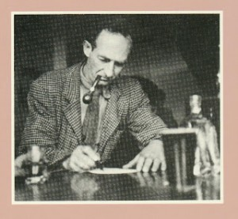**Fairburn at his desk.**

(url: http://www.counter-currents.com/wp-content/uploads/2012/03/Fairburn-A.-R.-D.-denys-trussell-300x277.jpg)

A.R.D. Fairburn was a New Zealand poet, essayist, journalist, and painter who, with other poet-countrymen, cultivated a national identity as distinct from that of a British Colony. Fairburn, a fourth generation new Zealander, was born to sugar company accountant Arthur and piano teacher and governess Teresa in Parnell, Auckland, New Zealand on February 2, 1904.

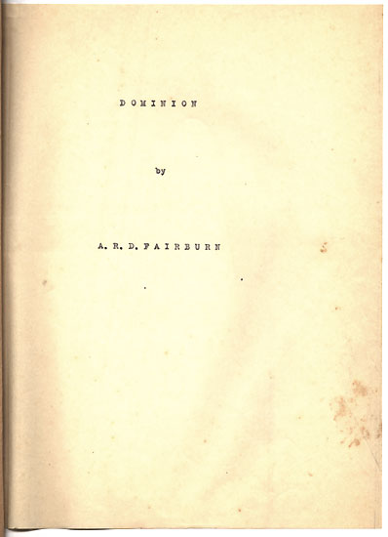**Typescript for *Dominion*, 1935, Housed with Other Digitized Manuscripts in Archive at The New Zealand Electronic Poetry Centre**

(url: http://www.nzepc.auckland.ac.nz/authors/fairburn/

dominion1.asp)

Fairburn’s poetry was primarily informed by the landscapes of New Zealand. He was best known for his critique of industrialism and advocacy of the social credit movement, central to which was his prescription for organic farming as essential to productive social and political life. These themes are found in the georgic style poetry of such works as ‘Dominion’ (1935), and the Marxist influenced prose arguments of essays such as ‘We New Zealanders’ (1944). Having briefly left New Zealand to expand his political education in London, he distanced himself from his metropolitan modernist contemporaries retreating to the English countryside to experience the roots of his ancestral attachment to the land there. Having developed his agricultural philosophy, he returned to New Zealand in 1932 to hold a series of editorial posts, eventually becoming a teacher of English, History, and Art at the University of Auckland and the prestigious Elam School of Fine Arts. In the late 1940s, he also took up painting and screening, most of his visual work focusing on the indigenous tradition with such pieces as ‘Study of Maori Rock Drawings.’ Although intensely concerned with fostering an independent New Zealand national identity, Fairburn was heavily influenced by the English literary tradition: the spiritual, anti-materialist themes of William Blake and other romanticists, the formal innovations of T.S. Eliot, and the thematic impulse of Edward Blunden, the latter two of whom were his contemporaries. Fairburn died on March 25, 1957 at the age of 53 from kidney cancer. He was a key figure in the development of a New Zealand national literature, and regarded as its foremost poet at the time of his death.

Fairburn’s short prose, such as ‘Some Aspects of New Zealand Art and Letters’ (1934), was witty and often satiric. His humorous tone carried over into his poetry as well, which was often parodic as with his *The Rakehelly Man* (1946). ‘Dominion’ (1935), Fairburn’s central epic lyrical achievement, is considered by many to be the most important political poem written in New Zealand. His work also foregrounds many of the spiritual and ecological issues that became a focus for political art in the post-modern era, not yet being addressed by most other modernists at that time in New Zealand or elsewhere. His feelings on abstract painters—such as Pablo Picasso—sum up nicely his general critique of all modernist aesthetics: their abstractions, he feels, seek to deconstruct humanity and not synthesize it, which was the role he saw for art in the twentieth century. This was, in his mind, connected to the increasingly capitalist focus of national identity, against which his social credit version of Marxism sought to push back with a more locally focused and holistic orientation, and was the main theme of most of his work.

[**Click Here to Listen**](http://www.teara.govt.nz/en/speech/79/fairburn-reading-his-poems)

**A.R.D. Fairburn Reading Poems - ‘Full Fathom Five,’ ‘A Farwell,’ and ‘Walking on My Feet’ in 1950s for Radio Broadcast Program entitled ‘New Zealand Poets’ Readings’; recording length: 3 minutes 53 seconds.**

(url: http://www.teara.govt.nz/en/speech/79/fairburn-reading-his-poems)

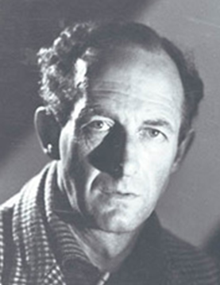**Fairburn, portrait.**

(url: http://www.nzepc.auckland.ac.nz/authors/fairburn/)

Fairburn was an eccentric man who vacillated between exuberant joy in human potential and melancholic depression at its decline. Many scholars want to place him in the politically liberal camp of Marxists for his work with social credit. Others desire to label him as a conservative for such views as those expressed posthumously in his *The Woman Problem* (1967), which emphasized the biological imperative of reproduction for the national good over a woman’s individual right to choose, as well as his expressed aversion to Semitic cultures for their nomadic tendencies and lack of rootedness, which he felt was essential to civilization’s health. These attempts to place him in one category or another usually result in a reductive understanding of a complicated man with a versatile artistic vision.

Though his work had minor formal and aesthetic innovations, he sought more to align himself with a classical tradition. This is especially visible in his early work, such as his first book of poetry *He Shall Not Rise* (1930), in poems such as ‘Odysseus,’ whose verse structure and substance—such as his georgic emphasis—allude to Greek predecessors. Still, his experiment with the modernist style of long poem in ‘Dominion*’* whereby he evokes an aggregation of parts from seemingly disparate wholes is in line with work of mainstream modernists such as T.S. Eliot and his *The Waste Land*.

[Click Here to Listen](http://publicaddress.net/2899#post)

Fairburn, Public Radio Address, ‘My Imaginary Journey,’ 1953

(url: http://publicaddress.net/2899#post)

**Selected List of Works**

Collected Works

*Poems, 1929–1941* (1943)

Strange Rendezvous (1952)

Collected Poems (1966)

*A.R.D. Fairburn Selected Poems* (1995)

Poetry

*He Shall Not Rise* (1930)

*The Rakehelly Man* *and Other Verses* (1946)

*Three Poems: Dominion, The Voyage, and To a Friend in the Wilderness* (1952)

Essays and Other Short Prose

‘Some Aspects of New Zealand Art and Letters’ (1934)

‘Who Said Red Ruin? An Examination of Newspaper Methods’ (1938)

*The Sky Is a Limpet: (A Pollytickle Parrotty): Also Four (4) Stories or Moral Feebles* (1940)

‘We New Zealanders: An Informal Essay’ (1944)

‘Hands Off the Tom Tom’ (1944)

*How to Ride a Bicycle in Seventeen Lovely Colours* (1946)

Letters

Lauris, Edmond (1981) The Letters of A. R. D. Fairburn, Auckland: Oxford University Press.

Posthumous Publications

*The Disadvantages of Being Dead* (1958)

The Woman Problem and Other Prose (1967)

**Further Reading**

Broughton, W.S. (1968) *A.R.D. Fairburn*, Wellington: A.H. and A.W. Reed.

Johnson, Olive (1958) A.R.D. Fairburn 1904–1957, A Bibliography of His Published Work,

Auckland: University of Auckland.

McNeish, James and Helen (1983) *Walking on my Feet: A.R.D. Fairburn 1904-1957: A Kind of*

*Biography*, Auckland: Collins.

Trussell, Denys John (1984) Fairburn, Auckland: Oxford University Press.